Spring JDBC

In Spring Core, we had the understanding on using Spring and the use of DI (Dependency Injection).
In this module, we will see how to deal with Databases using Spring framework.
Spring comes with a family of data access frameworks that integrate with a variety of data access technologies. You may use direct JDBC, iBATIS, or an object relational mapping (ORM) framework like Hibernate to persist your data. Spring supports all of these persistence mechanisms.

Problems of Plain Jdbc API :-

Problems of plain JDBC API as follows
1) Code Duplication : We need to write a lot of code before and after executing the query, such as creating connection, statement, etc…. is a major problem while using Jdbc API directly to access database, writing boilerplate code Over again is clear violation of the basic Object-Oriented (OO) principle of code resuse.This has some Side effects in terms of the Project cost,timelines and effort.
2) Resource Leakage problems
3)Exception-Handling problems
To Solve the above Problems The Springframework provides a solution by giving a robust and highly extensible Jdbc Abstraction F/w.
Spring Jdbc Approaches:-

JDBC and DAO module of Spring is used to build the data access layer of a Spring project

There are Two approaches in Spring JDBC f/w to develop the persistence logic.
1) Template Approach
2) Fine-Grained Object-oriented approach. (RdbmsOperation classes approach)

Note :- In computer programming, boilerplate code or boilerplate is the sections of code that have to be included in many places .
i.e. the programmer must write a lot of code to do minimal jobs
Template classes can help us in writing modular code with ease, without worrying about whether resources are closed properly or not.

DAO:-

It is the Design the Pattern which separates Persistence Logic from Business Logic
and provides code reusability on Persistence logic.
DAO classes can be developed with JDBC API,Hibernate,Ibatis Spring/JDBC etc....
Note :
Spring f/w provides the Declarative Exception-Handling mechanism to deal with database,

DataAccessException:-

org.springframework.dao.DataAccessException is the top most Exception in springJDBC and Spring ORM exception -hierarchy. DataAccessException is the child class of
Runtime Exception so all the SpringJdbc and ORM Exceptions are Unchecked Exceptions

JdbcTemplate :
The JdbcTemplate class is the central class in org.springframework.jdbc.core package .
It handles the creation and release of resources, which helps you avoid common errors such as forgetting to close the connection.
It performs the basic tasks of the core JDBC workflow such as statement creation and execution, leaving application code to provide SQL and extract results.
The JdbcTemplate class executes all types of SQL statements and stored procedure calls, performs iteration over ResultSets and extraction of returned parameter values.
It also catches JDBC exceptions and translates them to the generic, more informative, exception hierarchy defined in the org.springframework.dao package.
It is important to know that the JdbcTemplate class instances are threadsafe once configured. Meaning you can configure a single instance of a JdbcTeplate and then safely inject this shared reference into Multiple DAO’s.
The JdbcTemplate class is non-abstract class and can be instantiated using any of the following three constructors.
JdbcTemplate() : constructs a new JdbcTemplate object.This constructor
Is provided to allow Java Bean style of instantiation.
Note : when constructing an Object using this constructor we need to use setDataSource() method to set the dataSource before using this object to execute the statements.
JdbcTemplate(DataSource) : Constructs a new JdbcTemplate Object initializing it with the given dataSource to obtain connections for executing the requested statements.
JdbcTemplate(DataSource , boolean) : Constructs a new JdbcTemplate Object initializing it with the given dataSource to object connections for executing the requested statements,and the Boolean value describing the lazy initialization of the SQL Exception translator. If the Boolean value is true then the exception translator will not be initialized immediately.Instead it waits until this JdbcTemplate object is used to execute the statement. If the Boolean argument value is false then the exception translator is initialized while constructing this object. Using the JdbcTemplate(DataSource) constructor is the same as using the JdbcTemplate(dataSource,Boolean) constructor with the second argument as true. That means when a single argument constructor of JdbcTemplate is used the exception translator is not immediately initialized.

JdbcTemplate is providing below overloaded update()methods to implement DML statements.
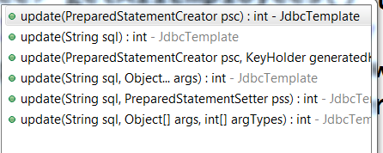

public int update(String sql):-

-->When the DML query is not having any placeholders then we will go for this method.
EX:- String sql=”DELETE FROM Employee WHERE empno=1001”;
Usage: jdbcTemplate.update(sql);

public int update(String sql,Object...args):-

-->When the DML query is having placeholders we will use this method.This method supports varargs feature of java.
Ex:- String sql=”insert into Employee values(?,?,?)”;
Usage:jdbcTemplate.update(sql,emp.getEmpNo(),emp.getName(),emp.getSalary());

public int update(String sql,Object[] args,int[] arqTypes):

-->When the query is having place holders & if we want to specify place holder types then we will use this method.
Ex:- String sql=”insert into Employee values(?,?,?)”;

Usage: jdbcTemplate.update(sql,new Object[]{emp.getEmpNo(),emp.getName(),emp.getSalary()},new int[]{Types.INTEGER ,Types.VARCHAR,Types.DOUBLE});

public int update(String sql,PreparedStatementSetter pss)
When the DML query is having placeholders we will use this method.
This method uses the given PreparedStatementSetter Object to set the bind
parameters.
The PreparedStatementSetter is a helper that sets the parameters of the PreparedStatement, PreparedStatementSetter interface contain only one method named as setValues, that takes PreparedStatement as an argument.
public void setValues(PreparedStatement pst)throws SQLException
Example :
EmployeeDAOImpl.java
@Repository("employeeDao")
public class EmployeeDAOImpl implements EmployeeDAO{
@Autowired
private JdbcTemplate jdbcTemplate;
public int createEmployee(Employee emp){
String sql="insert into Employee values(?,?,?)";
MyPreparedStatementSetter mpss=new MyPreparedStatementSetter(emp);
int count=jdbcTemplate.update(sql,mpss);
return count;
}
}
MyPreparedStatementSetter.java
public class MyPreparedStatementSetter implements PreparedStatementSetter{
Employee emp;
public MyPreparedStatement(Employee emp){
this.emp=emp;
}
public void setValues(PreparedStatement pst)throws SQLException{
pst.setInt(1,emp.getEid());
pst.setString(2,emp.getName());
pst.setDouble(3,emp.getSalary());
}
}
public int update(PreparedStatementCreator psc)
This method executes the DML/DDL Sql query
by using PreparedStatement object, The PreparedStatement is obtained by using the given PreparedStatementCreator.
The PreparedStatementCreator is an interface present in org.springfamework.jdbc.core package
PreparedStatementCreator interface contain only one method i,e.
public PreparedStatement createPreparedStatement( Connection connection)
Example :
EmployeeDAOImp.java
@Repository("employeeDao")
public class EmployeeDAOImpl implements EmployeeDAO{
@Autowired
private JdbcTemplate jdbcTemplate;
public void createEmployee(Employee emp){
MyPreparedStatementCreator mpsc=new MyPreparedStatementCreator(emp);
int count=jdbcTemplate.update(mpsc);
return count;
}
}
MyPreparedStatementCreator.java
public class MyPreparedStatementCreator implements PreparedStatementCreator{
private Employee emp;
public MyPreparedStatementCreator(Employee emp){
this.emp=emp;
}
public PreparedStatement createPreparedStatement (Connection con)throws SQLException{
PreparedStatement pst=con.prepareStatement("insert into Employee values(?,?,?)");
pst.setInt(1,emp.getEid());
pst.setString(2,emp.getName());
pst.setDouble(3,emp.getSalary());
return pst;
}
} 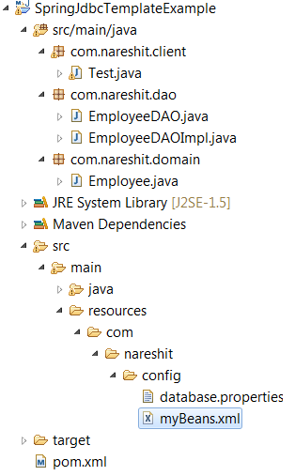
pom.xml
<project xmlns="http://maven.apache.org/POM/4.0.0" xmlns:xsi="http://www.w3.org/2001/XMLSchema-instance"
xsi:schemaLocation="http://maven.apache.org/POM/4.0.0 http://maven.apache.org/xsd/maven-4.0.0.xsd">
<modelVersion>4.0.0</modelVersion>
<groupId>com.nareshit</groupId>
<artifactId>SpringJdbcTemplateExample</artifactId>
<version>0.0.1-SNAPSHOT</version>
<packaging>jar</packaging>

<name>SpringJdbcTemplateExample</name>
<url>http://maven.apache.org</url>
<dependencies>
<dependency>
<groupId>org.springframework</groupId>
<artifactId>spring-context</artifactId>
<version>4.0.2.RELEASE</version>
</dependency>
<dependency>
<groupId>org.springframework</groupId>
<artifactId>spring-jdbc</artifactId>
<version>4.0.2.RELEASE</version>
</dependency>
<dependency>
<groupId>oracle.jdbc.driver</groupId>
<artifactId>ojdbc14</artifactId>
<version>10.2.0</version>
</dependency>
</dependencies>
</project>

myBeans.xml
<beans xmlns="http://www.springframework.org/schema/beans"
xmlns:context="http://www.springframework.org/schema/context"
xmlns:xsi="http://www.w3.org/2001/XMLSchema-instance"
xsi:schemaLocation="http://www.springframework.org/schema/beans
http://www.springframework.org/schema/beans/spring-beans-2.5.xsd
http://www.springframework.org/schema/context
http://www.springframework.org/schema/context/spring-context-2.5.xsd">

<context:component-scan base-package="com.nareshit.dao"/>
<context:property-placeholder
location="classpath:/com/nareshit/config/database.properties"/>

<!--
(OR)
<bean id="propertyPlaceholderConfigurer"
class="org.springframework.beans.factory.config.PropertyPlaceholderConfigurer">
<property name="locations">
<list>
<value>classpath:/com/nareshit/config/database.properties</value>
</list>
</property>
</bean> -->
<bean id="dataSource"
class="org.springframework.jdbc.datasource.DriverManagerDataSource">
<property name="driverClassName" value="${oracle.driver}"/>
<property name="url" value="${oracle.url}"/>
<property name="username" value="${oracle.username}"/>
<property name="password" value="${oracle.password}"/>
</bean>
<bean id="jdbcTemplate"
class="org.springframework.jdbc.core.JdbcTemplate">
<property name="dataSource" ref="dataSource"/>
</bean>
<bean id="employeeDao"
class="com.nareshit.dao.EmployeeDAOImpl">
<property name="jdbcTemplate" ref="jdbcTemplate"/>
</bean>
</beans>
database.properties
oracle.driver=oracle.jdbc.driver.OracleDriver
oracle.url=jdbc:oracle:thin:@localhost:1521:XE
oracle.username=system
oracle.password=manager
EmployeeDAO.java
package com.nareshit.dao;
import com.nareshit.domain.Employee;
public interface EmployeeDAO {
public int createEmployee(Employee employee);
public int deleteEmployee(int empNo);
public int updateEmployeeName(int empNo,String name);
}

EmployeeDAOImpl.java
package com.nareshit.dao;
import java.sql.Connection;
import java.sql.PreparedStatement;
import java.sql.SQLException;
import org.springframework.jdbc.core.JdbcTemplate;
import org.springframework.jdbc.core.PreparedStatementCreator;
import org.springframework.jdbc.core.PreparedStatementSetter;
import com.nareshit.domain.Employee;
public class EmployeeDAOImpl implements EmployeeDAO {
private JdbcTemplate jdbcTemplate;
public int createEmployee(Employee emp){
String sql="insert into emp values(?,?,?)";
int count=
jdbcTemplate.update(sql,emp.getEmpNo(),emp.getName(),emp.getSalary());
return count;
}
public int deleteEmployee(final int empNo) {
String sql="delete from emp where empno=?";
int count=jdbcTemplate.update(sql,
new PreparedStatementSetter(){
public void setValues(PreparedStatement ps)throws SQLException{
ps.setInt(1,empNo);
}
});
return count;
}
public int updateEmployeeName(final int empNo, final String name) {
int count=jdbcTemplate.update(
new PreparedStatementCreator(){
public PreparedStatement
createPreparedStatement(Connection connection)throws SQLException{
String sql="update emp set name=? where empno=?";
PreparedStatement pst=connection.prepareStatement(sql);
pst.setString(1,name);
pst.setInt(2, empNo);
return pst;
}
});
return count;
}
}

Employee.java
package com.nareshit.domain;
public class Employee {
private int empNo;
private String name;
private double salary;
public int getEmpNo() {
return empNo;
}
public void setEmpNo(int empNo) {
this.empNo = empNo;
}
public String getName() {
return name;
}
public void setName(String name) {
this.name = name;
}
public double getSalary() {
return salary;
}
public void setSalary(double salary) {
this.salary = salary;
}
}

Test.java
package com.nareshit.client;
import org.springframework.context.ApplicationContext;
import org.springframework.context.support.ClassPathXmlApplicationContext;
import com.nareshit.dao.EmployeeDAO;
import com.nareshit.domain.Employee;
public class Test{
public static void main( String[] args ){
ApplicationContext context=new ClassPathXmlApplicationContext("com/nareshit/config/myBeans.xml");
EmployeeDAO empDao=context.getBean("employeeDao",EmployeeDAO.class);
System.out.println("Testing of updateEmployeeName(-,-)");
int updateCount= empDao.updateEmployeeName(3001,"rama");
System.out.println("updateCount :"+updateCount);
System.out.println("Testing of deleteEmployee(-) ");
int deleteCount= empDao.deleteEmployee(3003);
System.out.println("deleteCount :"+deleteCount);

System.out.println("Testing of createEmployee(-)");
Employee emp=new Employee();
emp.setEmpNo(3004);
emp.setName("raju");
emp.setSalary(29000.0);
int insertCount=empDao.createEmployee(emp);
System.out.println("InsertCount ::"+insertCount);
}
}
Dao Supported classes:-
For every template class an associated Dao Support class given by Spring framework
In these classes corressponding template is declared as instance variables and associated setter and getter methods are defined.
JdbcTemplate class is associated with JdbcDaoSupport class this class is given by Spring framework

JdbcDaoSupport class Source Code :
public abstract class JdbcDaoSupport extends DaoSupport {

private JdbcTemplate jdbcTemplate;

public final void setDataSource(DataSource dataSource) {
if (this.jdbcTemplate == null ||
dataSource != this.jdbcTemplate.getDataSource()) {
this.jdbcTemplate = createJdbcTemplate(dataSource);
initTemplateConfig();
}
}

protected JdbcTemplate createJdbcTemplate(DataSource dataSource) {
return new JdbcTemplate(dataSource);
}
public final void setJdbcTemplate(JdbcTemplate jdbcTemplate) {
this.jdbcTemplate = jdbcTemplate;
initTemplateConfig();
}
public final JdbcTemplate getJdbcTemplate() {
return this.jdbcTemplate;
}
}

To Work with DaoSupport classes Take an user-defined Dao class as a Child class to XxxDaoSupport
class , set the DataSource object and to get the corresponding Xxxtemplate without explicitly declaraing the template as dependency we can call getXxxTemplate() method.

Example :

EmployeeDAO.java

public class EmployeeDAO extends JdbcDaoSupport {
public int createEmployee(Employee emp){
String sql="insert into employee values(?,?,?)";
int count=getJdbcTemplate().update(sql,emp.getEmpNo(),emp.getName(),emp.getSalary());
return count;
}
}

myBeans.xml
<beans
xmlns="http://www.springframework.org/schema/beans"
xmlns:xsi="http://www.w3.org/2001/XMLSchema-instance"
xsi:schemaLocation=
"http://www.springframework.org/schema/beans
http://www.springframework.org/schema/beans/spring-beans-2.5.xsd">

<bean id="dataSource"
class="org.springframework.jdbc.datasource.DriverManagerDataSource">
<property name="driverClassName"
value="oracle.jdbc.driver.OracleDriver"/>
<property name="url"
value="jdbc:oracle:thin:@localhost:1521:XE">
</property>
<property name="username"
value="system"/>
<property name="password" value="manager"/>
</bean>
<bean id="employeeDao"
class="com.nareshit.dao.EmployeeDAO">
<property name="dataSource" ref="dataSource"></property>
</bean>
</beans>

queryForXxx() methods :-
JdbcTemplate provides several convenience queryForXxx() methods to execute the select statements .

queryForInt(-) (in Spring 3.2.2 Deprecated )
public int queryForInt(String sql)
This method executes the select query and gives the result as an int value.
The Result of the Query is passed method is expected to be return a single row and Single coloum
If the Query does not returning exactly one row. It throws "org.springframework.dao.IncoreectResultSizeDataAccessException"
And if the query does not returning exactly one column it throws "org.springframework.jdbc.IncorrectResultSetColumnCountException"

public int queryForInt(String sql,Object[] params)
This method is similar to queryForInt(String sql)
but this method Have second argument that is used to set the bind parametes.
public int queryForInt(String sql,Object[] args,int[] Types)
this method is same as above method but this facilitates to describe the parameter types in addition.

queryForLong(- ) in Spring 3.2.2 Deprecated
public long queryForLong(String sql)
This method executes the select query and gives the result as a long value.
The Result of the Query is passed method is expected to be return a single row and Single coloum
public long queryForLong(String sql,Object[] args)
This method is similar to queryForLong(String sql)
but this method Have second argument that is used to set the bind parametes.
public long queryForLong(String sql,Object[] args,int[] Types)
this method is same as above method but this facilitates to describe the parameter types in addition.
queryForObject(-) :
public <T> T queryForObject(String sql,Class<T> requiredType, Object... params)throws DataAccessException

public <T> T queryForObject(String sql,Object[] params,Class<T> requiredType)throws DataAccessException

This method executes the given select query and the returned result will be directly mapped to the corresponding object type . The query is expected to be a single row/single column query;
params is used to set the bind parametes.
public <T> T queryForObject(String sql,Object[] params,int[] types,Class<T> requiredType)throws DataAccessException
this method is same as above method but this facilitates to describe the parameter types in addition.

queryForMap(-):
public Map<String,Object> queryForMap(String sql):
This method executes the given select query and the sql Query should result in a single row with one (OR) more column of any type.
The method returns a Map Object with one entry for each column with column name as a key and it’s values as an entry value.
public Map<String,Object> queryForMap(String sql,Object… params):
This method is similar to queryForMap(String sql)
but this method Have second argument that is used to set the bind parametes.
public Map<String,Object> queryForMap(String sql,Object[] params,int[] types):
this method is same as above method but this facilitates to describe the parameter types in addition.
queryForList(-):
public List<Map<String,Object>> queryForList(String sql)
This method executes the given select query and the sql Query should result in one (OR) more rows with one (OR) more column of any type.
The method returns a List of Map Objects. One Map object is created for each row ,one entry for each column with column names as a key and it’s value as an entry value.
public List<Map<String,Object>> queryForList(String sql,Object… params):
This method is similar to queryForList(String sql)
but this method Have second argument that is used to set the bind parametes.
public List<Map<String,Object>> queryForList(String sql,Object[] params,int[] types):
this method is same as above method but this facilitates to describe the parameter types in addition.
The following Example showing queryForXxx() methods usage.
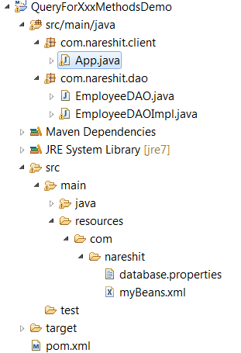

myBeans.xml
<beans xmlns="http://www.springframework.org/schema/beans"
xmlns:context="http://www.springframework.org/schema/context"
xmlns:xsi="http://www.w3.org/2001/XMLSchema-instance"
xsi:schemaLocation="http://www.springframework.org/schema/beans
http://www.springframework.org/schema/beans/spring-beans-2.5.xsd
http://www.springframework.org/schema/context
http://www.springframework.org/schema/context/spring-context-2.5.xsd">
<context:component-scan base-package="com.nareshit.dao" />
<context:property-placeholder location="classpath:/com/nareshit/database.properties" />
<bean id="dataSource" class="org.springframework.jdbc.datasource.DriverManagerDataSource">
<property name="driverClassName" value="${oracle.driver}" />
<property name="url" value="${oracle.url}"/>
<property name="username" value="${oracle.username}" />
<property name="password" value="${oracle.password}" />
</bean>
</beans>

database.properties
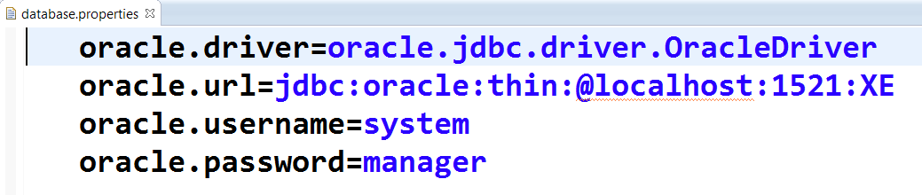
EmployeeDAO.java
package com.nareshit.dao;
import java.util.List;
import java.util.Map;
public interface EmployeeDAO{
int getDeptNo(int empno);
String getName(int empno);
double getSalary(int empno);
Map<String,Object> getEmployee(int empno);
List<Map<String,Object>> getAllEmployees();
}

EmployeeDAOImpl.java
package com.nareshit.dao;
import java.util.List;
import java.util.Map;
import javax.sql.DataSource;
import org.springframework.beans.factory.annotation.Autowired;
import org.springframework.jdbc.core.support.JdbcDaoSupport;
import org.springframework.stereotype.Repository;
@Repository("employeeDao")
public class EmployeeDAOImpl extends JdbcDaoSupport implements EmployeeDAO {
@Autowired
public EmployeeDAOImpl(DataSource dataSource){
setDataSource(dataSource);
}
public int getDeptNo(int empno){
return getJdbcTemplate().queryForInt("select deptno from emp where empno="+empno);
}
public String getName(int empno){
return getJdbcTemplate().queryForObject("select name from emp where empno="+empno,String.class);
}
public double getSalary(int empno){
return getJdbcTemplate().queryForObject("select salary from emp where empno=?",Double.class,empno);
}
public Map<String,Object> getEmployee(int empno){
return getJdbcTemplate().queryForMap("select name,deptno,salary from emp where empno=?",empno);
}
public List<Map<String,Object>> getAllEmployees(){
return getJdbcTemplate().queryForList("select empno,name,deptno,salary from emp");
}
}

App.java
package com.nareshit.client;
import java.util.List;
import java.util.Map;
import java.util.Map.Entry;
import java.util.Set;
import org.springframework.context.ApplicationContext;
import org.springframework.context.support.ClassPathXmlApplicationContext;
import com.nareshit.dao.EmployeeDAO;
public class App {
public static void main(String[] args) {
ApplicationContext context = new ClassPathXmlApplicationContext("com/nareshit/myBeans.xml");
EmployeeDAO employeeDao = context.getBean("employeeDao",EmployeeDAO.class);
System.out.println("Testing of getAllEmployees() ");
List<Map<String, Object>> list = employeeDao.getAllEmployees();
for (Map<String, Object> map1 : list) {
Set<String> keys = map1.keySet();
for (String key : keys) {
Object value = map1.get(key);
System.out.println(key + "=" + value);
}
System.out.println("-------------");
}
System.out.println("-------------------");
System.out.println("Testing of getEmployee(1001) ");
Map<String, Object> map2 = employeeDao.getEmployee(1001);
Set<Entry<String, Object>> set = map2.entrySet();
for (Entry<String, Object> entry : set) {
System.out.println(entry.getKey() + "=" + entry.getValue());
}
System.out.println("-------------------");
System.out.println("Testing of getName(1002) ");
System.out.println(employeeDao.getName(1002));
System.out.println("-------------------");
System.out.println("Testing of getDeptNo(1002) ");
System.out.println(employeeDao.getDeptNo(1002));
System.out.println("-------------------");
System.out.println("Testing of getSalary(1002) ");
System.out.println(employeeDao.getSalary(1002));
}
}

query() methods:-
JdbcTemplate class includes query() methods to prepare and execute the SQL queries . The Spring Jdbc abstraction framework provides three different types of callbacks to read the results after executing the SQL query using query() methods. The three callbacks of Spring Jdbc abstraction framework to retrieve the data are:
RowMapper
ResultSetExtractor
RowCallbackHandler

RowMapper :-
public List<T> query(String sql,RowMapper rm)
public List<T> query(String sql,Object[] params,RowMapper rm)
public List<T> query(String sql,RowMapper rm,Object… params)
RowMapper is a callback interface present in org.springframework.jdbc.core
and it has one method
public object mapRow(ResultSet rs,int rowNum)
The implementation classes of this interface needs to implement the mapRow() method,which takes the responsibility to process each row of data in the ResultSet. The mapRow() method should not call next() method on ResultSet.It requireds to extract values of the current row,process the data on per-row basis and map the current row values.
The mapRow() method implementations does not need to worry about handling the SQLException raised while reading the results.The SQLException will be caught and handled by the JdbcTemplate .
The mapRow() method can return an Object representing the result object for the current Row.
RowMapper objects are typically stateless and thus reusable; they are an ideal choice for implementing row-mapping logic in a single place.
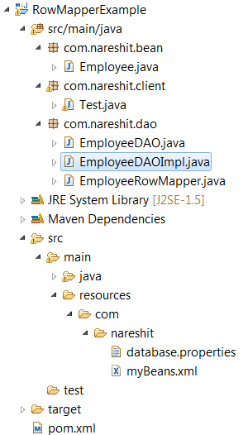

myBeans.xml
<beans xmlns="http://www.springframework.org/schema/beans"
xmlns:context="http://www.springframework.org/schema/context"
xmlns:xsi="http://www.w3.org/2001/XMLSchema-instance"
xsi:schemaLocation="http://www.springframework.org/schema/beans
http://www.springframework.org/schema/beans/spring-beans-2.5.xsd
http://www.springframework.org/schema/context
http://www.springframework.org/schema/context/spring-context-2.5.xsd">
<context:component-scan base-package="com.nareshit.dao" />
<context:property-placeholder
location="classpath:/com/nareshit/database.properties" />
<bean id="dataSource"
class="org.springframework.jdbc.datasource.DriverManagerDataSource">
<property name="driverClassName" value="${oracle.driver}" />
<property name="url" value="${oracle.url}" />
<property name="username" value="${oracle.username}" />
<property name="password" value="${oracle.password}" />
</bean>
<bean id="jdbcTemplate" class="org.springframework.jdbc.core.JdbcTemplate">
<property name="dataSource" ref="dataSource" />
</bean>
</beans>
database.properties
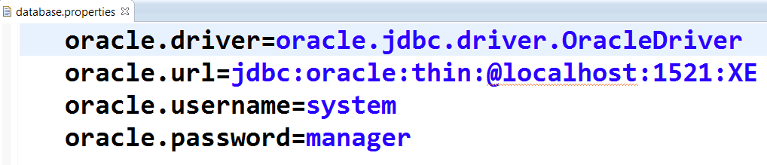

Employee.java
package com.nareshit.bean;
public class Employee {
private int empNo;
private String name;
private double salary;
//required setters and getters
}

EmployeeDAO.java
package com.nareshit.dao;
import java.util.List;
import com.nareshit.bean.Employee;
public interface EmployeeDAO {
public List<Employee> getAllEmployees();
public Employee getEmployee(int empNo);
}

EmployeeDAOImpl.java
package com.nareshit.dao;
import java.util.List;
import org.springframework.beans.factory.annotation.Autowired;
import org.springframework.jdbc.core.JdbcTemplate;
import org.springframework.stereotype.Repository;
import com.nareshit.bean.Employee;
@Repository("employeeDao")
public class EmployeeDAOImpl implements EmployeeDAO {
@Autowired
private JdbcTemplate jdbcTemplate;
public List<Employee> getAllEmployees() {
String sql="select empno,name,salary from EmployeeMaster";
EmployeeRowMapper erm=new EmployeeRowMapper();
List<Employee> list=jdbcTemplate.query(sql,erm);
return list;
}
public Employee getEmployee(int empNo){
Employee employee=null;
String sql="select empno,name,salary from EmployeeMaster where empno=?";
EmployeeRowMapper erm=new EmployeeRowMapper();
List<Employee> list=jdbcTemplate.query(sql,erm,empNo);
if(list.size()>0){
employee= list.get(0);
}
return employee;
}
}
EmployeeRowMapper.java
package com.nareshit.dao;
import java.sql.ResultSet;
import java.sql.SQLException;
import org.springframework.jdbc.core.RowMapper;
import com.nareshit.bean.Employee;
public class EmployeeRowMapper implements RowMapper<Employee> {
public Employee mapRow(ResultSet rs,int rowNum)throws SQLException{
Employee employee=new Employee();
employee.setEmpNo(rs.getInt("empNo"));
employee.setName(rs.getString("name"));
employee.setSalary(rs.getDouble("salary"));
return employee;

}

}

Test.java
Same as the above applications

ResultSetExtractor:

public T query(String sql,ResultSetExtractor rse)
public T query(String sql,Object[] params, ResultSetExtractor rse)
public T query(String sql, ResultSetExtractor rse,Object… params)

ResultSetExtractor is a callback interface present in org.springframework.jdbc.core
and it has one method
public T extractData(ResultSet rs)throws SQLException

The implementation classes of this interface needs to implement the extratData() method,which takes the responsibility to extracting results from a ResultSet,but does not need to wory about handling the SQLException raised while extracting the results.The SQLException will caught and handled by the JdbcTemplate.

The following EmployeeDAO.java shows how to use the ResultSetExtractor

EmployeeDAO.java

@Repository("employeeDao")
public class EmployeeDAO {
@Autowired
private JdbcTemplate jdbcTemplate;
public List<Employee> getAllEmployeeDetails(){
String sql="select * from employee ";
List<Employee> list=jdbcTemplate.query(sql,
new ResultSetExtractor<List<Employee>>(){
public List<Employee> extractData(ResultSet rs)
throws SQLException,DataAccessException {
List<Employee> list=new ArrayList<Employee>();
while(rs.next()){
Employee emp=new Employee();
emp.setEmpno(rs.getInt("empno"));
emp.setName(rs.getString("name"));
emp.setDeptno(rs.getInt("deptno"));
emp.setDeptname(rs.getString("deptname"));
emp.setSalary(rs.getDouble("salary"));
list.add(emp);
}
return list;
}//end of extractData()
});
return list;
}//end of getAllEmpolyeeDetails
public Employee getEmployee(int eno){
String sql="select * from employee where empno="+eno;
Employee emp=jdbcTemplate.query(sql,new ResultSetExtractor<Employee>(){
public Employee extractData(ResultSet rs)throws SQLException{
Employee emp=null;
if(rs.next()){
emp=new Employee();
emp.setEmpno(rs.getInt("empno"));
emp.setName(rs.getString("name"));
emp.setDeptno(rs.getInt("deptno"));
emp.setDeptname(rs.getString("deptname"));
emp.setSalary(rs.getDouble("salary"));
}
return emp;
}//end of extractData()
});
return emp;
}//end of getEmployee(-)
}//end of EmployeeDAO-class

RowCallbackHandler
public void query(String sql, RowCallbackHandler rch)
public void query(String sql, RowCallbackHandler rch,Object… params)
public void query(String sql, Object[] params,RowCallbackHandler rch)

RowCallbackHandler is a callback interface present in org.springframework.jdbc.core

and it has one method
public void processRow(ResultSet rs)throws SQLException
The implementation classes of this interface needs to implement the processRow() method,which takes the responsibility to extracting results from a ResultSet,but does not need to wory about handling the SQLException raised while extracting the results.The SQLException will caught and handled by the JdbcTemplate.
The processRow() method should not call next() method on the ResultSet.It requires to extract values of the current Row and process the data on per row basis.
The processRow() method cannot return any result.

The following EmployeeDAO.java shows how to use the RowCallbackHandler
EmployeeDAO.java
public class EmployeeDAO extends JdbcDaoSupport {
public List<Employee> getAllEmployeeDetails(){
final List<Employee> list=new ArrayList<Employee>();
String sql="select * from employee ";
getJdbcTemplate().query(sql,new RowCallbackHandler(){
public void processRow(ResultSet rs)
throws SQLException,DataAccessException {
Employee emp=new Employee();
emp.setEmpno(rs.getInt("empno"));
emp.setName(rs.getString("name"));
emp.setDeptno(rs.getInt("deptno"));
emp.setDeptname(rs.getString("deptname"));
emp.setSalary(rs.getDouble("salary"));
list.add(emp);
}//end of processRow()
});
return list;
}//end of getAllEmpolyeeDetails
public Employee getEmployee(int eno){
final Employee emp=new Employee();
String sql="select * from employee where empno="+eno;
getJdbcTemplate().query(sql,new RowCallbackHandler()
{//AIC
public void processRow(ResultSet rs)throws SQLException{
emp.setEmpno(rs.getInt("empno"));
emp.setName(rs.getString("name"));
emp.setDeptno(rs.getInt("deptno"));
emp.setDeptname(rs.getString("deptname"));
emp.setSalary(rs.getDouble("salary"));
}
}
);
return emp;
}//end of getEmployee(-)
}//end of EmployeeDAO-class

Q) when we can go for RowMapper?
if we don't want to control on extracting the ResultSet then we can go for RowMapper.
Q) when we can go for ResultSetExtractor?
if we want to control on processing the ResultSet then we can go for ResultSetExtractor.
Note : In JdbcTemplate ,Sql Parameters are represented by using a special place holder "?" symbol and bind it by position.
If the multiple positional parameter are there in a single sql query programmer may be confused while identifying the index's of parameters. To overcome this problem it is recommended to work with named parameters.
In the case of "Named Parameter” SQL parameters are defined by a starting column follow
By a name, rather than by position. In additional the named parameters are only supported in
SimpleJdbcTemplate and NamedParameterJdbcTemplate.
NamedParameterJdbcTemplate :
NamedParameterJdbcTemplate class is present in org.springframework.jdbc.core.namedparam package
The template class allowing the use of named parameters rather than traditional '?' placeholders.
This class delegates to a wrapped JdbcTemplate once the substitution from named parameters to JDBC style '?' placeholders is done at execution time. It also allows for expanding a List of values to the appropriate number of placeholders.
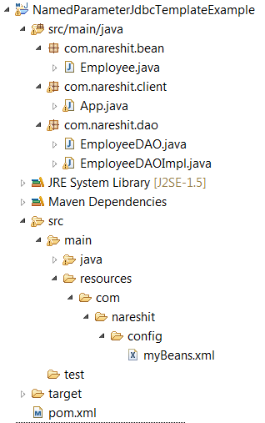

Employee.java
package com.nareshit.bean;
public class Employee {
private int empNo;
private String name;
private double salary;
public int getEmpNo() {
return empNo;
}
public void setEmpNo(int empNo) {
this.empNo = empNo;
}
public String getName() {
return name;
}
public void setName(String name) {
this.name = name;
}
public double getSalary() {
return salary;
}
public void setSalary(double salary) {
this.salary = salary;
}
}

myBeans.xml
<beans xmlns="http://www.springframework.org/schema/beans"
xmlns:context="http://www.springframework.org/schema/context"
xmlns:xsi="http://www.w3.org/2001/XMLSchema-instance"
xsi:schemaLocation="http://www.springframework.org/schema/beans
http://www.springframework.org/schema/beans/spring-beans-2.5.xsd
http://www.springframework.org/schema/context
http://www.springframework.org/schema/context/spring-context-2.5.xsd">

<context:component-scan base-package="com.nareshit.dao" />
<bean id="dataSource" class="org.springframework.jdbc.datasource.DriverManagerDataSource">
<property name="driverClassName" value="oracle.jdbc.driver.OracleDriver" />
<property name="url" value="jdbc:oracle:thin:@localhost:1521:XE"/>
<property name="username" value="system" />
<property name="password" value="manager" />
</bean>
<bean id="namedParameterJdbcTemplate"
class="org.springframework.jdbc.core.namedparam.NamedParameterJdbcTemplate">
<constructor-arg ref="dataSource" />
</bean>

</beans>

EmployeeDAO.java
package com.nareshit.dao;
import com.nareshit.bean.Employee;
public interface EmployeeDAO {
public int createEmployee(Employee emp);
}

EmployeeDAOImpl.java
package com.nareshit.dao;
import java.util.HashMap;
import java.util.Map;
import org.springframework.beans.factory.annotation.Autowired;
import org.springframework.jdbc.core.namedparam.NamedParameterJdbcTemplate;
import org.springframework.stereotype.Repository;
import com.nareshit.bean.Employee;
@Repository("employeeDao")
public class EmployeeDAOImpl implements EmployeeDAO{
@Autowired
private NamedParameterJdbcTemplate namedParameterJdbcTemplate;
public int createEmployee(Employee emp) {
String sql="insert into emp values(:empno,:name,:salary)";
Map<String,Object> map=new HashMap<String, Object>();
map.put("empno",emp.getEmpNo());
map.put("name",emp.getName());
map.put("salary",emp.getSalary());
int count=namedParameterJdbcTemplate.update(sql,map);
return count;
}

}
App.java
Same as above applications

SimpleJdbcTemplate :
SimpleJdbcTemplate class is present in org.springframework.jdbc.core.simple packge And It is a Java-5-based convenience wrapper for the classic Spring JdbcTemplate, taking advantage of varargs and autoboxing, and exposing only the most commonly required operations in order to simplify JdbcTemplate usage.
since Spring 3.1 in favor of JdbcTemplate and NamedParameterJdbcTemplate SimpleJdbcTemplate class is deprecated . The JdbcTemplate and NamedParameterJdbcTemplate now provide all the functionality of the SimpleJdbcTemplate.

Calling Stored Procedures with JdbcTemplate
- The Stored procedures contains input,output (OR) both the input and output parameters.
- After the execution of the SQL statements, the stored procedures return a value through the OUT parameters
- The StoredProcedures can returns Multiple ResultSets.

The Stored Procedures encapsulates the values within three types of parameters Such as IN,OUT, and INOUT.
The following parameters can ve declared while creating a procedure for the database.

IN- The IN parameter can be referenced by the Procedure. The value of the Parameter cannot be overwritten Procedure.
OUT- This Parameter cannot be referenced by the procedure,but the value of the parameter can be overwritten by the procedure.
INOUT- The parameter can be referenced by the Procedure and the value of the parameter can be Overwritten by the Procedure.
The spring f/w provides a support for calling stored procedures. JdbcTemplate class contain a method named as call(-,-) to execute the procedures.

prototype of call() method:-
public Map call(CallableStatementCreator cst,List declaredParameterTypes)
The first argument of the call() method is a CallableStatementCreator, which is a callback interface used by the JdbcTemplate to get the CallableStatement and to execute a procedure.
The CallableStatementCreator interface contains only one method with the following signature.

CallableStatementCreator method

public CallableStatement createCallableStatement(Connection con)throws SQLException

By using the given Jdbc Connection create CallableStatement object and the set the parameters inside the createCallableStatement() method.

The second argument of the call() method is a java.util.List, which encapsulates the list of declared SQLParameter objects

Stored Procedure :

create or replace procedure GETEMPLOYEEDETAILS(eno IN NUMBER,
ename OUT VARCHAR2, dname OUT VARCHAR2) is
begin
select name,deptname into ename,dname from emp where empno=eno;
end;
/
The above stored procedure takes one IN parameter and Two OUT parameters.
Now we will write a CallableStatementCreator callback to prepare a CallableStatement that can executes the above Stored Procedure .

MyCallableStatementCreator.java
public class MyCallableStatementCreator implements CallableStatementCreator{
private int eno;
public MyCallableStatementCreator(int eno){
this.eno=eno;
}
public CallableStatement createCallableStatement(Connection con)throws SQLException{
CallableStatement cst=con.prepareCall("{call GETEMPLOYEEDETAILS1(?,?,?)}");
cst.setInt(1,eno);
cst.registerOutParameter(2,Types.VARCHAR);
cst.registerOutParameter(3,Types.VARCHAR);
return cst;
}
}
The following EmployeeDAOImpl uses JdbcTemplate class to execute the Procedure

EmployeeDAOImpl.java
@Repository("employeeDao")
public class EmployeeDAOImpl implements EmployeeDAO{
@Autowired
private JdbcTemplate jdbcTemplate;
public void getEmployeeDetails(int empno) {
List<SqlParameter> list=new ArrayList<SqlParameter>();
list.add(new SqlParameter("eno",Types.INTEGER));
list.add(new SqlOutParameter("ename",Types.VARCHAR));
list.add(new SqlOutParameter("dname",Types.VARCHAR));
MyCallableStatementCreator mcsc=new MyCallableStatementCreator(empno);
Map<String,Object> results=jdbcTemplate.call(mcsc,list);
System.out.println("results :"+results);
}//end of getEmployeeDetails()
}

RDBMS Operation classes :
Spring Jdbc Abstraction Framework includes RDBMS operation classes,which provides a high level Object-Oriented abstraction to represent the RDBMS queries,updates,and stored procedures as threadsafe,reusable objects.
All the RDBMS classes are present in org.springframework.jdbc.object package.
org.springframework.jdbc.object.RdbmsOperation class is the root of the RDBMS operation classes.
RdbmsOperation class is a multithreaded, reusable type. The direct sub classes are SqlCall and SqlOperation.
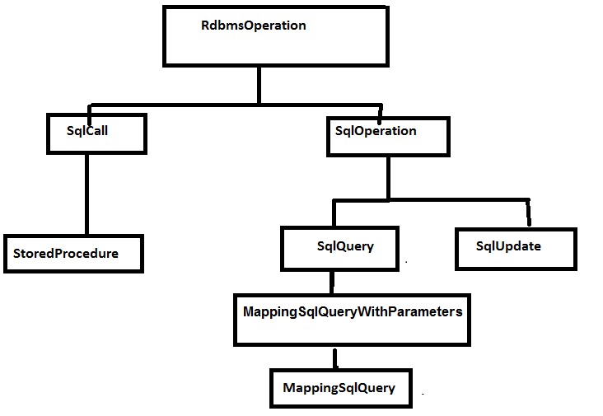
The SqlCall is used for representing and executing the stored procedures. The SqlOperation is used to represent the SQL query and updates using it's subtypes SqlQuery and SqlUpdate respectively.

The SqlQuery class:
The SqlQuery is an abstract class that provides an abstraction to
represent a reusable SQL query to access the Database.
The SqlQuery class contain a number of convenient execute() methods for executing the query represented by this Object.
The most widely and easy to use subclass of this class is MappingSqlQuery .
The MappingSqlQuery class simplifies the MappingSqlQuery WithParameters by reducing the parameters and context details.
MappingSqlQuery Object is a threadSafe,reusable , multithreaded object.
The sub classes of MappingSqlQuery needs to implement the abstract mapRow() method to convert each row of the resultSet into and domain Object.

MappingSqlQuery class mapRow() method signature:

public abstract Object mapRow(ResultSet rs,int rowNum)throws SQLException

The following example shows how to use the MappingSqlQuery

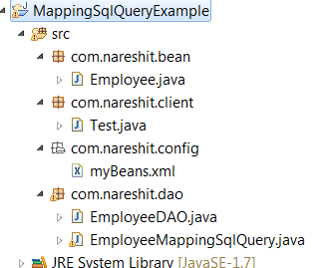

Employee.java
package com.nareshit.bean;
public class Employee {
private int empno,deptno;
private String deptname,name;
private double salary;
//required setters and getters
}

EmployeeMappingSqlQuery.java
package com.nareshit.dao;
import java.sql.ResultSet;
import java.sql.SQLException;
import javax.sql.DataSource;
import org.springframework.jdbc.core.SqlParameter;
import org.springframework.jdbc.object.MappingSqlQuery;
import com.nareshit.bean.Employee;
public class EmployeeMappingSqlQuery extends MappingSqlQuery<Employee>{
public EmployeeMappingSqlQuery(DataSource ds,String sql) {
super(ds,sql);
}
public Employee mapRow(ResultSet rs,int rowNumber)throws SQLException{
Employee emp=new Employee();
emp.setEmpno(rs.getInt(1));
emp.setName(rs.getString(2));
emp.setDeptno(rs.getInt(3));
emp.setDeptname(rs.getString(4));
emp.setSalary(rs.getDouble(5));
return emp;
}
}

EmployeeDAO.java
package com.nareshit.dao;
import java.sql.Types;
import java.util.List;
import javax.sql.DataSource;
import org.springframework.jdbc.core.SqlParameter;
import com.nareshit.bean.Employee;
public class EmployeeDAO {
private DataSource dataSource;
public void setDataSource(DataSource dataSource) {
this.dataSource = dataSource;
}
public List<Employee> getAllEmployees(){
String sql="select *from employee";
EmployeeMappingSqlQuery sqlQuery=new EmployeeMappingSqlQuery(dataSource,sql);
List<Employee> list=sqlQuery.execute();
return list;
}
public Employee getEmployee(int eno){
Employee emp=null;
String sql="select *from employee where empno=?";
EmployeeMappingSqlQuery sqlQuery=new EmployeeMappingSqlQuery(dataSource,sql);
sqlQuery.declareParameter(new SqlParameter("empno",Types.INTEGER));
List<Employee> list=sqlQuery.execute(eno);
if(list.size()>0){
emp=list.get(0);
}
return emp;
}
}

myBeans.xml
<?xml version="1.0" encoding="UTF-8"?>
<beans xmlns="http://www.springframework.org/schema/beans"
xmlns:xsi="http://www.w3.org/2001/XMLSchema-instance"
xsi:schemaLocation="http://www.springframework.org/schema/beans
http://www.springframework.org/schema/beans/spring-beans-3.0.xsd">
<bean id="dataSource"
class="org.springframework.jdbc.datasource.DriverManagerDataSource">
<property name="driverClassName" value="oracle.jdbc.driver.OracleDriver" />
<property name="url" value="jdbc:oracle:thin:@localhost:1521:XE" />
<property name="username" value="system" />
<property name="password" value="manager" />
</bean>
<bean id="empDao" class="com.nareshit.dao.EmployeeDAO">
<property name="dataSource" ref="dataSource" />
</bean>
</beans>

Test.java
package com.nareshit.client;
import java.util.List;
import org.springframework.beans.factory.BeanFactory;
import org.springframework.beans.factory.xml.XmlBeanFactory;
import org.springframework.core.io.ClassPathResource;
import org.springframework.core.io.Resource;
import com.nareshit.bean.Employee;
import com.nareshit.dao.EmployeeDAO;

public class Test {
public static void main(String[] args) {
Resource r=new ClassPathResource("com/nareshit/config/myBeans.xml");
BeanFactory factory=new XmlBeanFactory(r);
EmployeeDAO empDao=(EmployeeDAO)factory.getBean("empDao");
List<Employee> list=empDao.getAllEmployees();
System.out.println("Response of getAllEmployees");
for(Employee emp:list) {
System.out.println(emp);
}
Employee emp=empDao.getEmployee(1001);
System.out.println("Response of getEmployee(1001) :");
System.out.println(emp);
}
}

SqlUpdate class :
The SqlUpdate is a concrete class and contain the number of convenient update() methods for executing the sqlupdates .
The following EmployeeDAOImpl.java shows how to use the SqlUpdate
EmployeeDAOImpl.java
@Repository("employeeDao")
public class EmployeeDAOImpl {
@Autowired
private DataSource dataSource;
public int updateEmployeeName(int empNo,String name) {
String sql="update employee set name=? where empno=?";
SqlUpdate sqlUpdate=new SqlUpdate(dataSource,sql);
sqlUpdate.declareParameter(new SqlParameter(Types.VARCHAR));
sqlUpdate.declareParameter(new SqlParameter(Types.INTEGER));
int count= sqlUpdate.update(name,empNo);
return count;
}
public int deleteEmployee(int empNo) {
String sql="delete from employee where empno=?";
SqlUpdate sqlUpdate=new SqlUpdate(dataSource,sql);
sqlUpdate.declareParameter(new SqlParameter(Types.INTEGER));
int count=sqlUpdate.update(empNo);
return count;
}
}
StoredProcedure :
The storedProcedure class is an abstract class ,which provides an
abstraction for representing the RDBMS stored procedures.
To use the StoredProcedure functionality take an user-defined class as a sub class to StoredProcedure.

The following MyStoredProcedure.java shows the StoredProcedure implementation class that represents the procedure.
MyStoredProcedure.java
public class MyStoredProcedure extends StoredProcedure{
public MyStoredProcedure(DataSource dataSource,String procedure){
super(dataSource,procedure);
declareParameter(new SqlParameter("eno",Types.INTEGER));
declareParameter(new SqlOutParameter("ename",Types.VARCHAR));
declareParameter(new SqlOutParameter("dname",Types.VARCHAR));
compile();
}
}
The following EmployeeDAOImpl.java shows how to use the storedProcedure implementation
EmployeeDAOImpl.java
@Repository("employeeDao")
public class EmployeeDAOImpl{
@Autowired
private DataSource dataSource;
public void getEmployeeDetails(final int empno){
String procedure="GETEMPLOYEEDETAILS";
Map<String,Object> paramMap=new HashMap<String,Object>();
paramMap.put("eno",empno);
MyStoredProcedure storedProcedure=new MyStoredProcedure(dataSource, procedure);
Map<String,Object> resultMap=storedProcedure.execute(paramMap);
System.out.println(resultMap);
}
}

